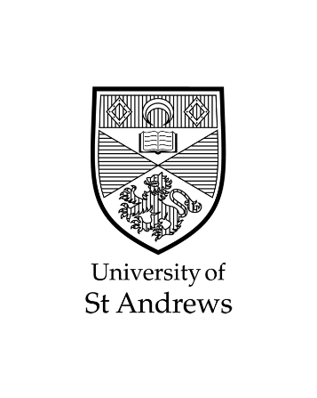

**PARTICIPANTS WANTED**

**Project Title**

Medical Pronunciation App

This study is being conducted as part of my, Joanna Moreland, Honours Degree research study in the School of Computer Science at the University of St Andrews.

We invite you to participate in a research project that aims to make an application to teach medical practitioners how to pronounce medical terms. The application will display a list of words and play a recording of a selected word with the correct pronunciation to the user. The user will then record their own attempt to pronounce the word that will be compared to the original, correct recording. The application will then advise the user regarding their own pronunciation so that they can improve their pronunciation.

Participants will be asked to interact with the application in a way that educates them and fill out a questionnaire on their experience. Research will occur in the Computer Science buildings at the North Haugh in March of 2020. Participants will fill out an anonymous questionnaire on their experience. The process should take a maximum of 20 minutes.

If you are interested, please get in contact using the details below. You will then be given a Participant Information Sheet that further details my research and have the opportunity to ask questions, before being asked whether you consent to participate.

**Contact Details**

Researcher: Joanna Moreland, Ishbel Duncan (Supervisor)

Contact Details: [jelm@st-andrews.ac.uk](mailto:jelm@st-andrews.ac.uk), 07801 581048

[Ishbel.Duncan@st-andrews.ac.uk](mailto:Ishbel.Duncan@st-andrews.ac.uk), (0)1334 463270